

Mission Travel Guide

Guatemala

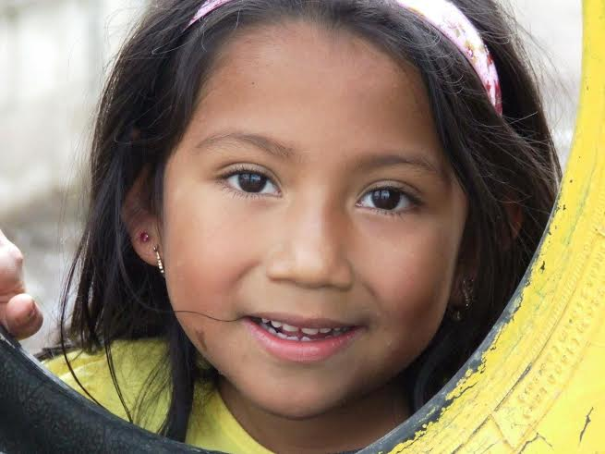



C:\Program Files (x86)\Microsoft Office\MEDIA\CAGCAT10\j0301076.wmf

Where in the World?

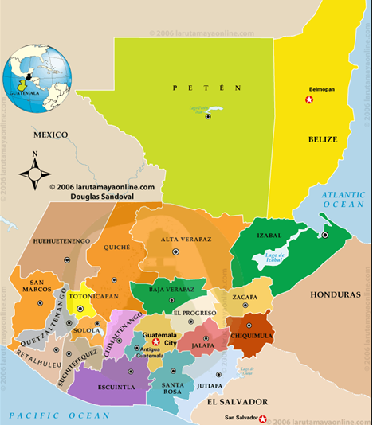

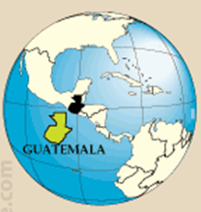



We will fly into

Guatemala City,

Guatemala

Final Destinations

are Panajachel

and San Pablo in

Solola, Guatemala

Mission Trip Expectations

**Spiritual Qualifications**

1. Since we will be going in the name of Jesus and St. Peter’s Church, the members of the mission team need to be followers of Jesus. These types of mission trips are rarely great opportunities for evangelism among team members because the demands of travel, cross-cultural adjustment and ministry require spiritual resources that folks without Christ don’t yet have.
2. Members of the mission team need to be team players, willing to submit gladly to the trip’s leaders and to work out conflict and disappointment with each other quickly and effectively.

**Ministry Abilities**:

1. Pray for others.
2. Give a Testimony: When did you first believe? How did you come to know Christ?

**Preparation:**

Because of the importance of team-building, every team member needs to commit to:

1. Attending all preparatory team meeting.
2. Attending Debrief meeting after returning to Tallahassee.

**Partner Raising:**

One of the faith-building and team-building activities is raising the support (both financial and spiritual) that the team needs before going. Therefore, every member of the team is expected to:

1. Raise the majority of the total cost of the trip through personal resources or (preferably) through raising up partners (through sending letters to family and friends, talking with folks about the trip, etc.) and giving others an opportunity to participate in the trip, even if they can’t go.
2. Raise the rest of the total cost of the trip through team fund raising activities. These activities need to actively build teamwork and bless those who receive the goods or service for which they are paying/bidding.

If someone funds their own trip and does not actively seek others to pray for them, the trip inevitably becomes "their trip" rather than a work of the body of Christ. This leads to a person feeling there is little or no accountability to or encouragement from others.

**Trip Purpose:**

All mission trips have three overarching purposes.

1. Bringing encouragement. We want to be a blessing to those who receive us in Guatemala. We want to leave people with hearts that are full of thanksgiving for our coming rather than with relief at our leaving.
2. Building relationships. Throughout most of the world relationships are much more important than tasks. Therefore, one of our greatest desires is to spend time with the people of Guatemala, getting to know them as well as we can in a limited time. The most successful trips often have no pictures of what we accomplished (buildings built, patients seen, etc.) but only pictures of the friends that we left behind.
3. Establishing partnerships. We are partnering with Pastor Trinidad and Rosa and Jim and Cindy Betsill so that they can be more effective in strengthening the Church and reaching the lost. We also believe that the partnership is mutual and that we will receive from them far more than we give.

**Debriefing:**

A crucial aspect of the whole experience is the reflection that mission trips stirs in our hearts. In order to encourage that reflection and to make sure that everyone who goes is able to process the experience in a healthy way, team members are expected to attend debriefing session(s).

**There are three things that need to be accomplished in preparation for ministry in Guatemala**

1. A commitment in your own heart that God is calling you to this ministry
2. Successful completion of the trip preparation and training
3. A body of believers who are committed to this ministry in such a way that they provide funding, prayer support, and are willing to commission your trip with prayer and the laying on of hands.

The People of Guatemala

Guatemala’s colorful indigenous peoples are descendants of the ancient Mayans. 23 different native tongues are spoken; you will most likely encounter the beautiful sound of Ka’ Chikel and Tzu ’zuhil. Many of these people also speak Spanish as a second language.

The Ladino Guatemalans are largely descendants of the Spanish conquerors of this area. They are much more modern in their lifestyle and have a general history of oppressing the indigenous.

Expatriate/gringos- Pana and the Lake Atitlan basin attract many counter-culture minded, mysticism-oriented, hedonistic or rugged- individual types who are typically “turned off” to Christianity and Christians. They often see the numerous local Spanish-speaking congregations as loud nuisances.

Guatemala’s civil war (1961-1996) damaged a considerable portion of the country’s infrastructure. Grinding poverty, ignorance and poor living conditions are common and breed theft, human and child exploitation and violence.

Opportunities to Serve

**Children and Youth Ministry:**

Partnering with Pastor Trinidad, Rosa, and Ely as well as Joe and Cindy Betsill:

Activities include:

1. Bible school
2. crafts
3. music
4. sports

**Small Project:**

This project will be determined by The Betsill’s to help them in their ministry.

**Women of Faith:**

This will be determined by the Betsill’s and the Women of Faith regarding the water filters & stoves we have sponsored.

Passports

**New Application for a U.S. Passport:**

To obtain a passport for the first time, you need to go in person with two photographs of yourself, proof of U.S. citizenship, valid form of photo identification such as a driver’s licence and a check or money order.

You need to apply in person if:

* you are applying for a U.S. passport for the first time
* if your expired U.S. passport is not in your possession
* if your previous U.S. passport has expired and was issued more than 15 years ago
* if your previous U.S. passport was issued when you were under age 16
* if your currently valid U.S. passport has been lost or stolen.

Locations:

1. Leon County Clerk of Circuit Court

313 S. Calhoun St., Suite 101,

Tallahassee, FL 32301 (850) 577-4060

1. FSU International Programs

A5500 University Center

Tallahassee, FL 32306  (850) 645-9714

**Renewal of a U.S. Passport:**

You can renew by mail if:

* Your most recent passport is available to submit and it is not damaged
* you received the passport within the past 15 years
* you were over age 16 when it was issued
* you still have the same name, or can legally document your name change
* If your passport has been, altered or damaged, you cannot apply by mail. You must apply in person.

**Please visit** [**http://travel.state.gov/passport/get/get_840.html**](http://travel.state.gov/passport/get/get_840.html) **for specific instructions and forms you will need to renew or apply for a first time passport. *** Don’t Forget to Sign your Passport!**

Before Going to Guatemala…

**Fundraising**

The total cost will be approximately: $1500 per person.

**Letters:**

Personal Letters can be written to family, friends, and co-workers with the intention of raising money for your trip. In your letter it is important to write the purpose of your trip, the dates you will be away, a deadline for them to send their checks and the instructions on how to write out their checks. Their donations are tax deductible only if checks are written correctly. Include the Fundraising/Prayer Support Card when sending your letter.

* Checks should be written out to "St. Peter's Anglican Church"
* "Guatemala Mission" needs to be written on the memo line. Your name should **NOT** be on the memo line. Be sure and stress this.
* Include the Fundraising/Prayer Support Card.
* Fundraising Support Card and check should be returned to St. Peter’s Church.
* Prayer Support will be kept by your supporter.
* Write **March 31** as the deadline for money to be sent.

**Create a Facebook Page:**

Invite people to join your group asking them to prayerfully and financially support your mission trip. This is a great way to update your supporters.

**Thank you notes:**

It is important to send a note acknowledging the generosity of the giver.

**Email Itinerary:**

Email your itinerary to family and friends so they can pray specific prayers for that day.

**Group Fundraiser:**

It is also important to have a group fundraiser to involve your church family and community. This also serves as a way for group members to work together on a project before going overseas. Conflict may arise and it is important to know how to resolve issues prior to going on a long trip together. Even if all your money has been raised, you still must participate in a group fundraiser.

**Vaccinations**

Required: Current tetanus vaccination. You can receive this from your primary care physician or pediatrician.

Before every trip up-date your routine vaccines: Measles-mumps-rubella (MMR), diphtheria-tetanus-pertussis, varicella (chickenpox), polio vaccine, and your yearly flu shot.

Hepatitis A- CDC recommends this vaccine because you can get hepatitis A through contaminated food or water in Guatemala, regardless of where you are eating or staying.

Typhoid- You can get typhoid through contaminated food or water in Guatemala. CDC recommends this vaccine for most travelers, especially if you are staying with friends or relatives, visiting smaller cities or rural areas, or if you are an adventurous eater.

Malaria- Antimalarial NOT needed where we are going. It is required for rural areas only at altitudes below 1,500 m (4,921 ft). None in Antigua, Guatemala City, or Lake Atitlán. For more information go to CDC Website.  [http://wwwn.cdc.gov/travel/default.aspx](https://3c-lxa.mail.com/mail/client/dereferrer?redirectUrl=http%3A%2F%2Fwwwn.cdc.gov%2Ftravel%2Fdefault.aspx)

**Insurance**

Evacuation Insurance is required. This will be purchased for the group by the Misison Director. You will be given a copy at the Packing Party to keep with you and one to leave at home with your family.

**In General: Clothing and other packing recommendations**

Try to travel light by bringing your clothes and personal effects in your carry-on (also great if some of the clothes, etc. can be left here). That allows use of most of checked baggage for ministry items and donations.

Guatemala is the "land of eternal spring" and temperatures are warm (80 degree F max in day) and cool (60's at night- bring a sweater or light jacket) year round. Rainy season is May to October so prepare for rain every day. You can buy inexpensive ponchos in Pana. Gore-tex shoes or low boots are great. Good hats needed year round.

* No short shorts- Shorts must be no more than 3-4 inches above the knee. This is strictly enforced. You will be asked to change if seen in short shorts.
* No 2 piece bathing suits.
* Bring good walking shoes or hiking boots.
* Wear Sun Hat and wear sunscreen during the morning and afternoon. Reapply sunscreen half way through the day.

Packing Check List

* Passport
* Copy of evacuation insurance
* Money – enough to cover personal expenses including gifts & snacks & zip lining.
* Flight Itinerary
* Travel Belt for under clothes
* Work clothes for the day and clean evening clothes
* Casual clothes for travel days and diversion day
* Bathing Suit (2 piece not allowed)
* Walking shoes or hiking boots
* Sandals
* Flip flops for shower
* Personal prescription medications in original bottles
* Tylenol or Ibuprofen
* Immodium– let your team leader know if you start having loose stool before taking it. You may need to be treated for Travelers Diarrhea.
* Motion sickness medications if you have trouble flying or riding in a car for long periods of time.
* Bug spray
* Personal hygiene products- soap, tooth brush and tooth paste, lotion, razor, shampoo, conditioner, deodorant, hairspray
* Sun screen (sweat proof)
* Sun glasses
* Sun Hat
* Light weight rain jacket/poncho
* Camera/extra digital storage
* Journal/writing tablet
* Writing Utensil
* Bible
* Flashlight, extra batteries
* Hand sanitizer
* Hand wipes
* Travel TP or tissue packs
* Snacks for first travel day.
* Work Gloves

Once in Guatemala…

You will land in Guatemala City and leave immediately for your final destination, Panajachel. Panajachel is about 3 1/2 hours by van from Guatemala City. You will stay in Panajachel for the week and travel back and forth to San Pablo, Jaibalito and Panimache.

**Money**

Guatemala’s currency is the “queztale” (named after famous bird)- exchange rate is usually around 8.0 quetzales to $1 US. Our ministry partners and your team leaders will take care of exchanging money.

**Personal Safety**

Stay with the group at all times. Don’t venture out alone. Lock your doors.

Don’t flash your cash. Watch out for pick-pockets, especially on market days. A money belt or equivalent is a good idea. Leave your valuables at home. Anything you leave unattended in a public or semi-public place is likely to be stolen.

**Health and Hygiene**

Don’t drink the water. You will have bottled water available to drink and use to brush your teeth. Keep a bottle of water with you at all time. You are at a higher altitude than you are used to and can easily get dehydrated.

Bring Hand sanitizer and use it often.

Toilet paper is generally available in Pana – but do not flush it down the toilet. It is not likely to be available in San Pablo, Jaibalito or Panimache, so it’s a good idea to have some with you at all times.

Don’t eat street vendor food or drinks. Fruit and vegetables must be disinfected before eating.

We ask that you try not to waste food or order more than you can eat. Please also let us know, in advance, if you are a strict vegetarian or have special dietary requirements.

**Photography**

Please ask for and receive permission before taking photographs of individuals or groups. Digital photos can be developed in Panajachel at reasonable prices, if you wish. The gift of a photograph can be especially meaningful to the indigenous folks-many have none.

**Gifts**

Indiscriminate gift-giving to the indigenous or locals can create problems- jealousy, envy, strife, etc. Please check with your team leader for permission and suggestions.

Please do not pull out or show gifts of any kind in a medical clinic, Bible school or indigenous village setting without having previously cleared the “give away” plan.

**Alcohol, Tobacco and Drugs**

Prohibited for all missionaries.

**Team Reflection Times**

The team will meet every morning for prayer & directions for the day and each night for prayer, reflection and debriefing.

Back from Guatemala…

**Debriefing:**

A crucial aspect of the whole experience is the reflection that mission trips stirs in our hearts. In order to encourage that reflection and to make sure that everyone who goes is able to process the experience in a healthy way, team members are expected to attend debriefing session(s).